Heaven’s light is our guide



RAJSHAHI UNIVERSITY OF ENGINEERING & TECHNOLOGY
Department of Mechatronics Engineering

Lab Report

Experiment No.:05
Experiment Name: LCD Interfacing using Atmega32 with Proteus Simulation.

Submitted By: | Submitted To:
Samia Afsana  ID: 2008055  3rd Year, Odd Semester  Department of Mechatronics Engineering  Rajshahi University of Engineering & Technology, Rajshahi-6204. | Md Mehedi Hasan  Assistant Professor  Department of Mechatronics Engineering  Rajshahi University of Engineering & Technology, Rajshahi-6204.
Md. Sakib Hassan Chowdhury
Lecturer
Department of Mechatronics Engineering
Rajshahi University of Engineering & Technology, Rajshahi-6204.

Date of Experiment: 11 May, 2024
Date of Submission: 18 May, 2024

MTE 3104
Microcontroller and Interfacing Sessional
Experiment No.: 05
Experiment Name: LCD Interfacing using Atmega32 with Proteus Simulation.

Objectives:
- To interface an LCD with the Atmega32 microcontroller.
- To simulate the interfacing using Proteus software.
- To display characters and strings on the LCD.
- To understand the initialization and command sequence for the LCD.

Theory:
A Liquid Crystal Display (LCD) is a flat-panel display technology commonly used in screens for computers, televisions, and instrument panels. The 16x2 LCD module used in this lab has 16 columns and 2 rows. It communicates with the microcontroller through a parallel data interface, which includes a data bus and control signals. The 16×2 LCD display is a very basic module commonly used in DIYs and circuits. The 16×2 translates a display of 16 characters per line in 2 such lines. In this LCD, each character is displayed in a 5×8pixel matrix.
The Atmega32 microcontroller will be programmed to send appropriate commands and data to the LCD to display the desired information. The commands will include initializing the LCD, clearing the display, and setting the cursor position, while the data will include the characters to be displayed.

LCD 16×2 Pin Diagram:
- Pin1 (Ground/Source Pin): Used to connect the GND terminal of the microcontroller unit or power source.
- Pin2 (VCC/Source Pin): Used to connect the supply pin of the power source.
- Pin3 (V0/VEE/Control Pin): Used to connect a changeable POT that can supply 0 to 5V.
- Pin4 (Register Select/Control Pin): Used to connect a microcontroller unit pin and obtains either 0 or 1(0 = data mode, and 1 = command mode).
- Pin5 (Read/Write/Control Pin): Connected to a microcontroller unit pin to get either 0 or 1 (0 = Write Operation, and 1 = Read Operation).
- Pin 6 (Enable/Control Pin): Connected to the microcontroller unit & constantly held high to execute Read/Write process
- Pins 7-14 (Data Pins): Used to send data to the display.
- Pin15 (+ve pin of the LED): This pin is connected to +5V
- Pin 16 (-ve pin of the LED): This pin is connected to GND.

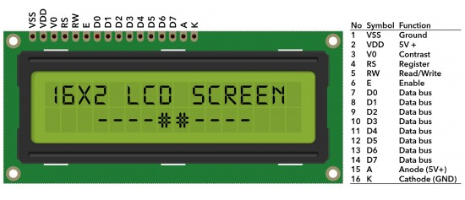

Figure- 5.1: 16x2 Liquid Crystal Display (LCD) Configuration [1].

Functional Registers
The 16x2 LCD module operates using two main registers:
- Command Register: Stores instructions for the LCD, such as initializing the display, clearing the screen, and controlling the cursor position.
- Data Register: Stores the ASCII values of characters to be displayed on the screen. Data is sent to this register when RS (Register Select) is set to 1.

Features of the 16x2 LCD Module:
- Operating Voltage: 4.7V-5.3V.
- Current Consumption: 1mA without backlight.
- Character Display: Each of the 32 characters (16 per line) is formed in a 5x8 pixel box.
- Modes of Operation: Supports 4-bit and 8-bit modes.
- Backlight Options: Available in blue and green.
- Custom Characters: Capable of displaying user-defined characters [2].

In this lab, we aim to interface a 16x2 LCD with the Atmega32 microcontroller and simulate the design using Proteus. LCDs are widely used in embedded systems for displaying information due to their simplicity and ease of use. The Atmega32, a popular AVR microcontroller, will be programmed to send data and commands to the LCD to display text.

Working Principle:
- The data pins (D4-D7) of the LCD were connected to PORTC (PC4-PC7) of the Atmega32.
- The control pins RS (Register Select), RW (Read/Write), and E (Enable) of the LCD were connected to PORTD (PD0, PD1, and PD2) respectively.
- The LCD was initialized by setting the data direction registers of the connected ports to output.
- The LCD was implemented initialization sequence.
- The functions were written to send commands and data to the LCD.
- The given test message is displayed by sending characters to the LCD.

Required Components:
- Atmega32 Microcontroller
- 16x2 LCD
- Power
- Wire
- Ground
- Resistor
- Potentiometer
- Push Button

Code:

#define F_CPU 80000000UL
#include <avr/io.h>
#include "lcdlib/lcd_lib.h"

int main(void)
{ _delay_ms(100);
LCDinit();
LCDWriteStringXY(2,0,"SAMIA AFSANA"); //X column, Y row
LCDWriteStringXY(4,1,"2008055");
while (1)
{
}

Figures:

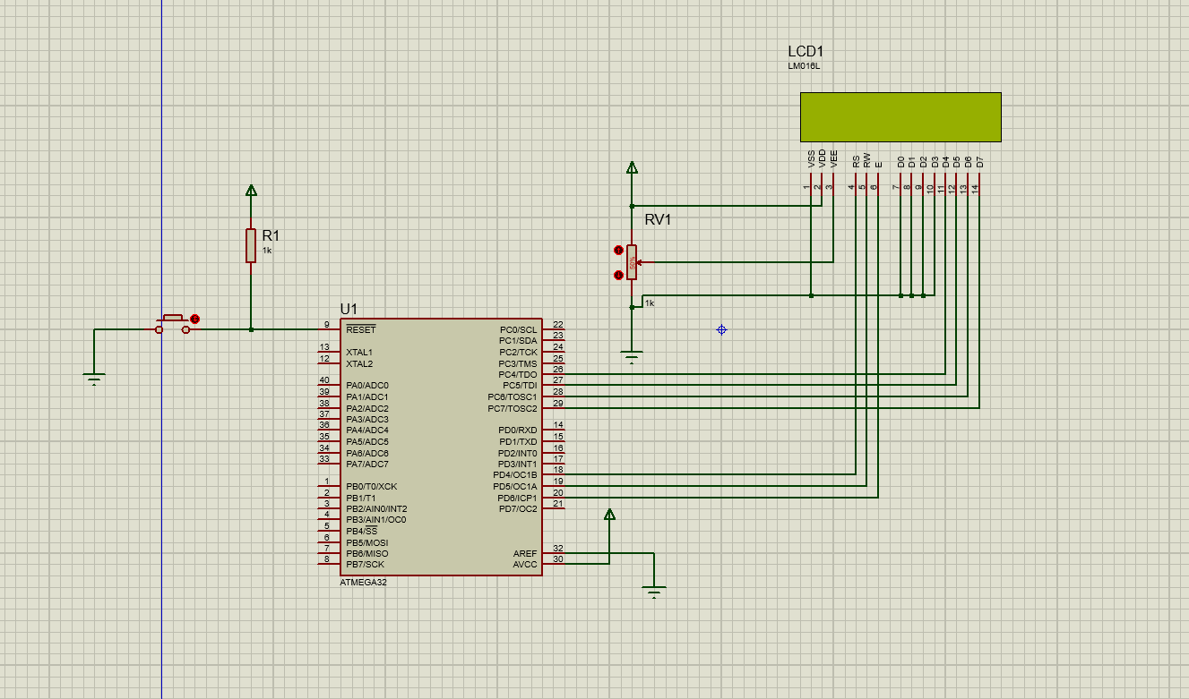

Figure-5.2: LCD Display OFF phase in simulation.

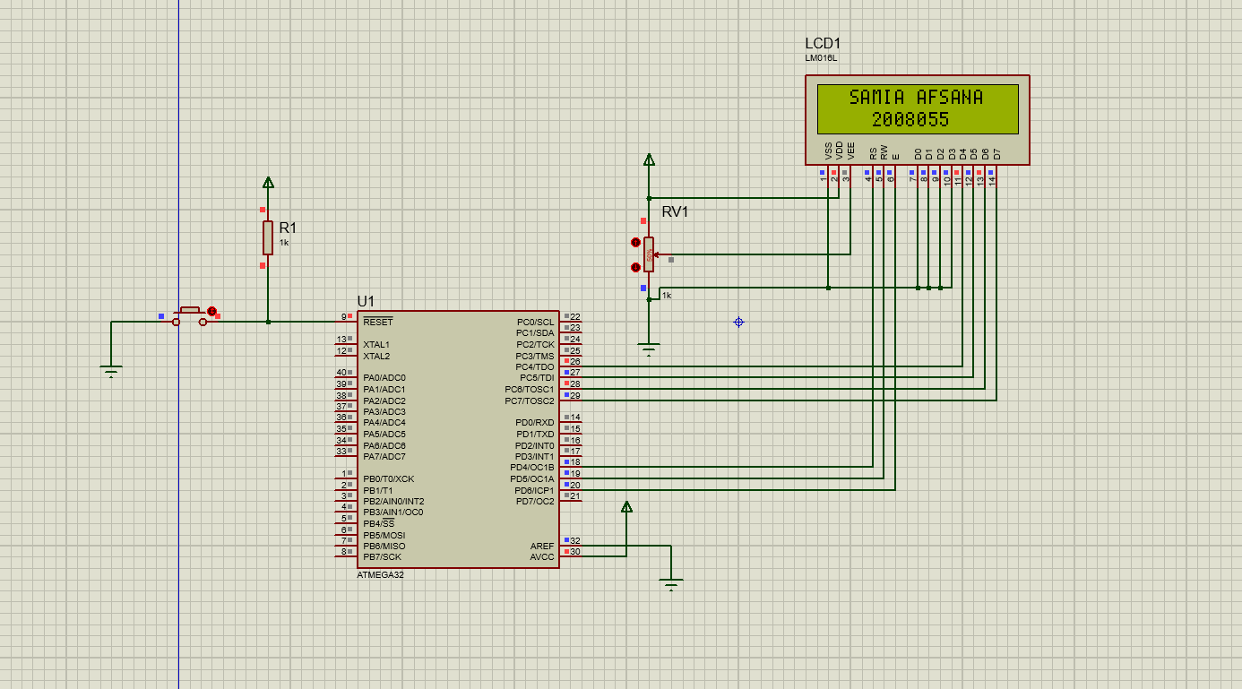

Figure-5.3: LCD Display ON phase in simulation.

Discussion:
During the simulation, the circuit was successfully implemented using LCD in Proteus software. The Atmega32 microcontroller accurately controlled the 16x2 LCD to display the provided text from the buttons. The given test message was displayed in the 16x2 LCD screen properly. The interfacing between the microcontroller and the LCD display was seamless, demonstrating the effectiveness of the design.

Practical Uses:
- Embedded Systems Development: LCD interfacing with Atmega32 allows developers to create user interfaces for embedded systems. This is crucial in applications like industrial automation, home automation, and automotive electronics.
- Data Display: In various monitoring and control systems, such as weather monitoring stations, LCDs can be used to display real-time data such as temperature, humidity, pressure, etc.
- Alarm Systems: LCDs can be used to display status messages, alerts, and warnings in alarm systems
- Instrumentation: LCDs can be used to display measured parameters such as voltage, current, frequency, etc. in scientific instruments and measurement devices.

Conclusion:
The experiment on LCD interfacing using Atmega32 with Proteus simulation provided valuable insights into the process of integrating a microcontroller with an LCD display. Through the simulation, we were able to observe the communication between the Atmega32 microcontroller and the LCD module, witnessing how data is transmitted and displayed on the screen. We gained insights into the significance of timing and synchronization in ensuring accurate data transmission and display on the LCD. This experiment served as a practical exercise in applying theoretical knowledge to simulate and validate hardware interfacing concepts, paving the way for future projects and experiments in embedded systems design.

References:

[2] 16x2 LCD [Online]. Available:
https://kut.ai/microcontrollers/16x2-lcd-display

[1] 16x2 LCD Pin Configuration, Features [Online]. Available:
https://www.elprocus.com/lcd-16x2-pin-configuration-and-its-working/ (2013 - 2024)

